**Azure Devops Feeds**

Artifacts Feeds are organizational constructs that allow you to store, manage, and group your packages and control who to share it with. Feeds are not package-type dependent. You can store all the following package types in a single feed: npm, NuGet, Maven, Python, and Universal packages.

**Create feeds**

Public feeds are project-scoped feeds in a public project.

1. Select **Artifacts**.

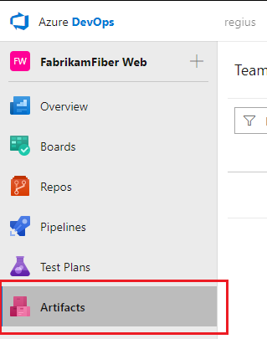

1. Select **Create Feed**.

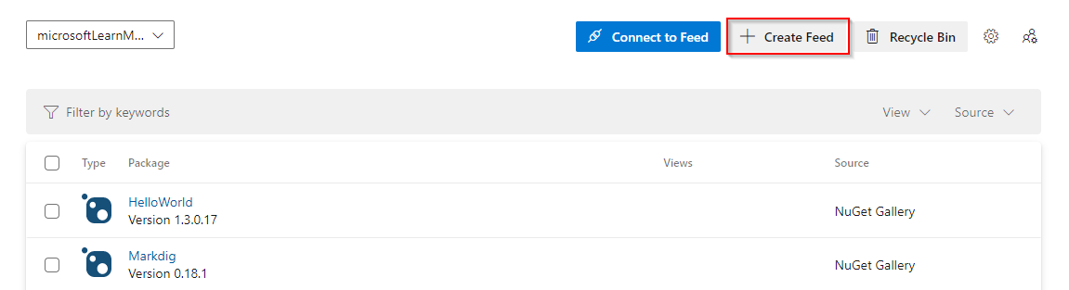

1. Give your feed a **Name**, and then select **Project** for your feed's scope.

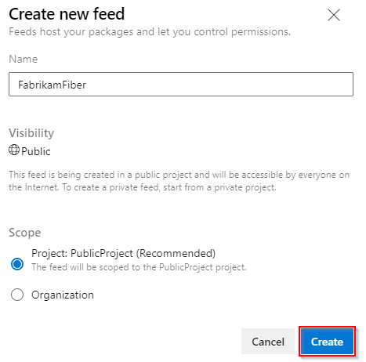

1. Select **Create** when you are done.

**Delete a feed**

1. Select **Artifacts**, and then select your feed from the dropdown menu.
2. Select the gear icon gear icon to navigate to your feed's settings.

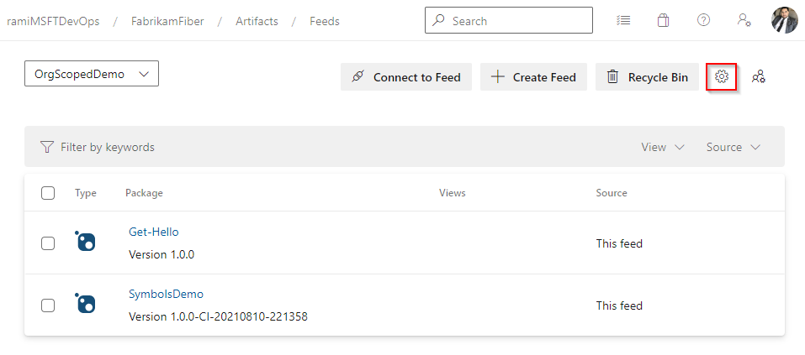

1. Select **Delete feed**.
2. Select **Delete** when you are ready.

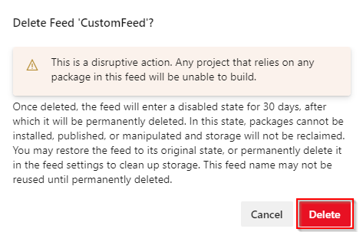

**Restore deleted feeds**

If you accidentally delete a feed, Azure Artifacts provides a 30 days window to recover your feed to its original state. After the 30 days, the feed will be deleted permanently. During the recovery window, the name of the feed remains reserved, packages are unavailable for download, and write access is suspended for that feed.

You can view the feeds that are pending permanent deletion in the feed picker dropdown list under the **Deleted Feeds** tab.

1. Select **Artifacts**.
2. Select the feed picker dropdown menu, and then select **Deleted Feeds**

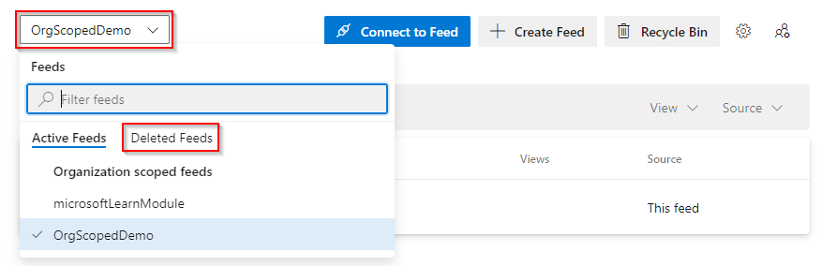

1. Select the feed you want to restore, and then select **Feed Settings**.

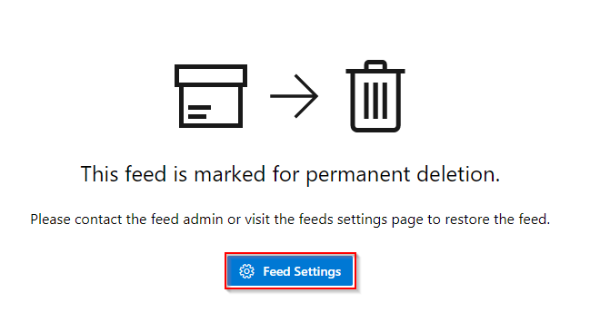

1. Select **Restore Feed**.

**Permanently deleting a feed**

A feed pending deletion will still use storage space. If you want to permanently delete your feed before the 30 days period is up, you can do this as follows:

1. Select **Artifacts**.
2. Select the feed picker dropdown menu, and then select **Deleted Feeds**



1. Select the feed you want to restore, and then select **Feed Settings**.



1. Select **Permanently Delete Feed**, and then select **Delete**.

Once the feed is permanently deleted, users won't be able to view or restore its packages. The feed name will be available for reuse 15 minutes after the deletion.

# Configure upstream sources

With upstream sources, you can use a single feed to store the packages you generate and the packages you consume from public registries such as npmjs.com, NuGet.org, Maven Central, and PyPI.org. Once you've enabled an upstream source, every time you install a package from the public registry, Azure Artifacts will save a copy of that package in your feed.

## Create a new feed and enable upstream sources

**Note**

Upstream sources are not supported in public feeds.

1. From within your project, select **Artifacts**.



1. Select **Create Feed**.



1. Give your feed a **Name** and choose its **visibility**, and **scope** settings. Make sure you check the **Include packages from common public sources** checkbox to enable upstream sources.

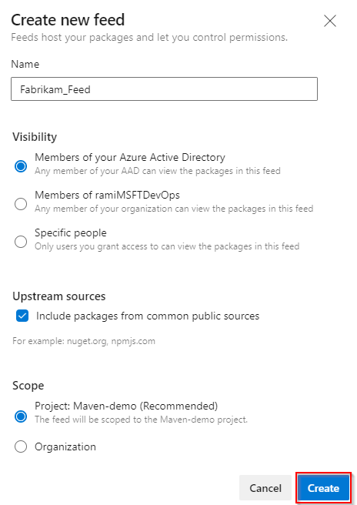

1. Select **Create** when you are done.

**Important**

Maven snapshots are not supported in upstream sources.

## Enable upstream sources in an existing feed

**Note**

Custom public upstream sources are only supported with npm registries.

1. Select the gear icon button to access your feed's settings.
2. Select **Upstream sources**.
3. Select **Add upstream source**.
4. Select **Public source**, and then select the **Public source**. (Example Maven Central ([*https://repo.maven.apache.org/maven2/*](https://repo.maven.apache.org/maven2/)) for Maven central)
5. Select **Add** when you are done.

**Note**

Azure Artifacts support Maven Central, Google Maven Repository, Gradle Plugins, and JitPack as upstream sources for Maven.

## Add a feed in your organization as an upstream source

1. Select the gear icon button to access your feed's settings.
2. Select **Upstream sources**.
3. Select **Add Upstream**.
4. Select **Azure Artifacts feed in this organization**.
5. Select the feed you would like to add from the dropdown menu.
6. Select the package types you want to use, select the **View** and name your upstream source.
7. Select **Save** when you are done.

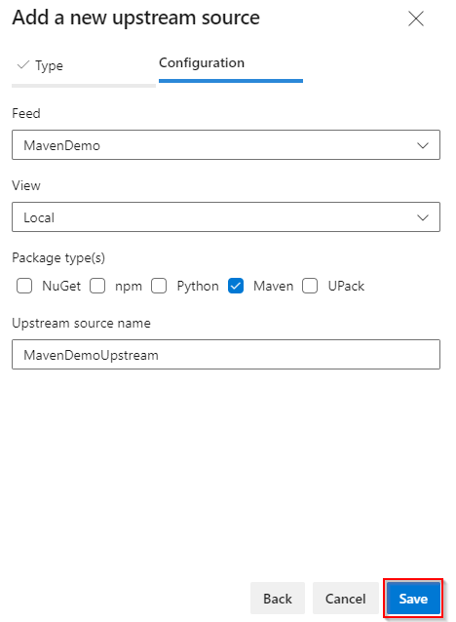

## Add a feed in a different organization as an upstream source

**Note**

Universal Packages are only supported in upstream sources within the same organization.

1. Select the gear icon button to access your feed's settings.
2. Select **Upstream sources**.
3. Select **Add Upstream**.
4. Select **Azure Artifacts feed in another organization**.
5. Enter your **Azure DevOps Services feed locator**. Example: azure-feed://myOrg/myProject/myFeed@local.
6. Select the **Package type(s)** you want to use and enter an **Upstream source name**.
7. Select **Save** when you are done.

